**Software**

**Software**is more than just a program code. A program is an executable code, which serves some computational purpose. Software is considered to be collection of executable programming code, associated libraries and documentations. Software, when made for a specific requirement is called **software product.**

**Engineering** on the other hand, is all about developing products, using well-defined, scientific principles and methods.

Need of Software Engineering

The need of software engineering arises because of higher rate of change in user requirements and environment on which the software is working.

* **Large software -**It is easier to build a wall than to a house or building, likewise, as the size of software become large engineering has to step to give it a scientific process.
* **Scalability-**If the software process were not based on scientific and engineering concepts, it would be easier to re-create new software than to scale an existing one.
* **Cost-**As hardware industry has shown its skills and huge manufacturing has lower down he price of computer and electronic hardware. But the cost of software remains high if proper process is not adapted.
* **Dynamic Nature-**The always growing and adapting nature of software hugely depends upon the environment in which user works. If the nature of software is always changing, new enhancements need to be done in the existing one. This is where software engineering plays a good role.
* **Quality Management-**Better process of software development provides better and quality software product.

## Characteristics of good software

A software product can be judged by what it offers and how well it can be used. This software must satisfy on the following grounds:

* Operational
* Transitional
* Maintenance

Well-engineered and crafted software is expected to have the following characteristics:

### **Operational**

This tells us how well software works in operations. It can be measured on:

* Budget
* Usability
* Efficiency
* Correctness
* Functionality
* Dependability
* Security
* Safety

### **Transitional**

This aspect is important when the software is moved from one platform to another:

* Portability
* Interoperability
* Reusability
* Adaptability

### **Maintenance**

This aspect briefs about how well a software has the capabilities to maintain itself in the ever-changing environment:

* Modularity
* Maintainability
* Flexibility
* Scalability

Software Development Life Cycle

Software Development Life Cycle (SDLC) is a process used by the software industry to design, develop and test high quality softwares. The SDLC aims to produce a high-quality software that meets or exceeds customer expectations, reaches completion within times and cost estimates.

SDLC is a process followed for a software project, within a software organization. It consists of a detailed plan describing how to develop, maintain, replace and alter or enhance specific software. The life cycle defines a methodology for improving the quality of software and the overall development process.

* SDLC is the acronym of Software Development Life Cycle.
* It is also called as Software Development Process.
* SDLC is a framework defining tasks performed at each step in the software development process.
* ISO/IEC 12207 is an international standard for software life-cycle processes. It aims to be the standard that defines all the tasks required for developing and maintaining software.

SDLC Models

There are various software development life cycle models defined and designed which are followed during the software development process. These models are also referred as Software Development Process Models. Each process model follows a Series of steps unique to its type to ensure success in the process of software development.

Following are the most important and popular SDLC models followed in the industry −

* Waterfall Model
* Iterative Model
* Spiral Model
* V-Model
* Big Bang Model

Other related methodologies are Agile Model, RAD Model, Rapid Application Development and Prototyping Models.

## What is SDLC?

SDLC is a process followed for a software project, within a software organization. It consists of a detailed plan describing how to develop, maintain, replace and alter or enhance specific software. The life cycle defines a methodology for improving the quality of software and the overall development process.

The following figure is a graphical representation of the various stages of a typical SDLC.

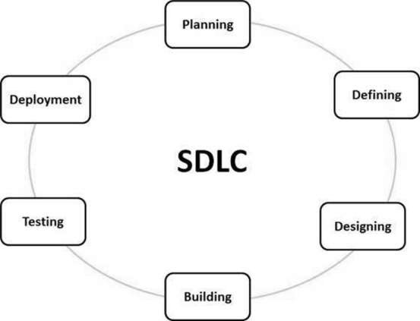

**Waterfall Model**

The Waterfall Model was the first Process Model to be introduced. It is also referred to as a **linear-sequential life cycle model**. It is very simple to understand and use. In a waterfall model, each phase must be completed before the next phase can begin and there is no overlapping in the phases.

The Waterfall model is the earliest SDLC approach that was used for software development.

The waterfall Model illustrates the software development process in a linear sequential flow. This means that any phase in the development process begins only if the previous phase is complete. In this waterfall model, the phases do not overlap.

Waterfall Model - Design

Waterfall approach was first SDLC Model to be used widely in Software Engineering to ensure success of the project. In "The Waterfall" approach, the whole process of software development is divided into separate phases. In this Waterfall model, typically, the outcome of one phase acts as the input for the next phase sequentially.

The following illustration is a representation of the different phases of the Waterfall Model.

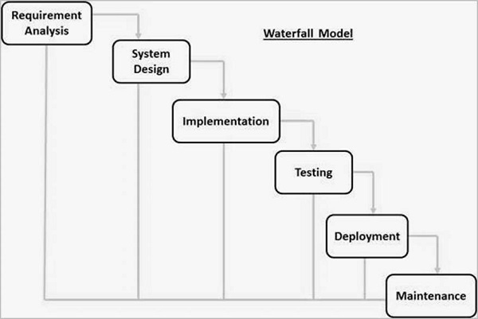

The sequential phases in Waterfall model are −

* **Requirement Gathering and analysis** − All possible requirements of the system to be developed are captured in this phase and documented in a requirement specification document.
* **System Design** − The requirement specifications from first phase are studied in this phase and the system design is prepared. This system design helps in specifying hardware and system requirements and helps in defining the overall system architecture.
* **Implementation** − With inputs from the system design, the system is first developed in small programs called units, which are integrated in the next phase. Each unit is developed and tested for its functionality, which is referred to as Unit Testing.
* **Integration and Testing** − All the units developed in the implementation phase are integrated into a system after testing of each unit. Post integration the entire system is tested for any faults and failures.
* **Deployment of system** − Once the functional and non-functional testing is done; the product is deployed in the customer environment or released into the market.
* **Maintenance** − There are some issues which come up in the client environment. To fix those issues, patches are released. Also to enhance the product some better versions are released. Maintenance is done to deliver these changes in the customer environment.

All these phases are cascaded to each other in which progress is seen as flowing steadily downwards (like a waterfall) through the phases. The next phase is started only after the defined set of goals are achieved for previous phase and it is signed off, so the name "Waterfall Model". In this model, phases do not overlap.

Waterfall Model - Application

Every software developed is different and requires a suitable SDLC approach to be followed based on the internal and external factors. Some situations where the use of Waterfall model is most appropriate are −

* Requirements are very well documented, clear and fixed.
* Product definition is stable.
* Technology is understood and is not dynamic.
* There are no ambiguous requirements.
* Ample resources with required expertise are available to support the product.
* The project is short.

Waterfall Model - Advantages

The advantages of waterfall development are that it allows for departmentalization and control. A schedule can be set with deadlines for each stage of development and a product can proceed through the development process model phases one by one.

Development moves from concept, through design, implementation, testing, installation, troubleshooting, and ends up at operation and maintenance. Each phase of development proceeds in strict order.

Some of the major advantages of the Waterfall Model are as follows −

* Simple and easy to understand and use
* Easy to manage due to the rigidity of the model. Each phase has specific deliverables and a review process.
* Phases are processed and completed one at a time.
* Works well for smaller projects where requirements are very well understood.
* Clearly defined stages.
* Well understood milestones.
* Easy to arrange tasks.
* Process and results are well documented.

Waterfall Model - Disadvantages

The disadvantage of waterfall development is that it does not allow much reflection or revision. Once an application is in the testing stage, it is very difficult to go back and change something that was not well-documented or thought upon in the concept stage.

The major disadvantages of the Waterfall Model are as follows −

* No working software is produced until late during the life cycle.
* High amounts of risk and uncertainty.
* Not a good model for complex and object-oriented projects.
* Poor model for long and ongoing projects.
* Not suitable for the projects where requirements are at a moderate to high risk of changing. So, risk and uncertainty is high with this process model.
* It is difficult to measure progress within stages.
* Cannot accommodate changing requirements.
* Adjusting scope during the life cycle can end a project.
* Integration is done as a "big-bang. at the very end, which doesn't allow identifying any technological or business bottleneck or challenges early.

**Iterative Model**

In the Iterative model, iterative process starts with a simple implementation of a small set of the software requirements and iteratively enhances the evolving versions until the complete system is implemented and ready to be deployed.

An iterative life cycle model does not attempt to start with a full specification of requirements. Instead, development begins by specifying and implementing just part of the software, which is then reviewed to identify further requirements. This process is then repeated, producing a new version of the software at the end of each iteration of the model.

Iterative Model - Design

Iterative process starts with a simple implementation of a subset of the software requirements and iteratively enhances the evolving versions until the full system is implemented. At each iteration, design modifications are made and new functional capabilities are added. The basic idea behind this method is to develop a system through repeated cycles (iterative) and in smaller portions at a time (incremental).

The following illustration is a representation of the Iterative and Incremental model −

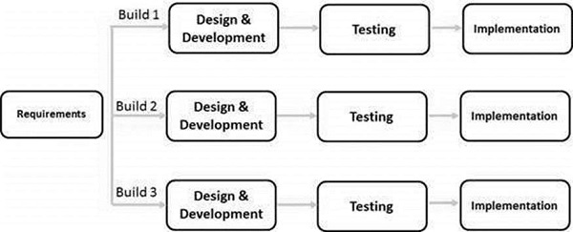

Iterative and Incremental development is a combination of both iterative design or iterative method and incremental build model for development. "During software development, more than one iteration of the software development cycle may be in progress at the same time." This process may be described as an "evolutionary acquisition" or "incremental build" approach."

In this incremental model, the whole requirement is divided into various builds. During each iteration, the development module goes through the requirements, design, implementation and testing phases. Each subsequent release of the module adds function to the previous release. The process continues till the complete system is ready as per the requirement.

The key to a successful use of an iterative software development lifecycle is rigorous validation of requirements, and verification & testing of each version of the software against those requirements within each cycle of the model. As the software evolves through successive cycles, tests must be repeated and extended to verify each version of the software.

Iterative Model - Application

Like other SDLC models, Iterative and incremental development has some specific applications in the software industry. This model is most often used in the following scenarios −

* Requirements of the complete system are clearly defined and understood.
* Major requirements must be defined; however, some functionalities or requested enhancements may evolve with time.
* There is a time to the market constraint.
* A new technology is being used and is being learnt by the development team while working on the project.
* Resources with needed skill sets are not available and are planned to be used on contract basis for specific iterations.
* There are some high-risk features and goals which may change in the future.

Iterative Model - Pros and Cons

The advantage of this model is that there is a working model of the system at a very early stage of development, which makes it easier to find functional or design flaws. Finding issues at an early stage of development enables to take corrective measures in a limited budget.

The disadvantage with this SDLC model is that it is applicable only to large and bulky software development projects. This is because it is hard to break a small software system into further small serviceable increments/modules.

The advantages of the Iterative and Incremental SDLC Model are as follows −

* Some working functionality can be developed quickly and early in the life cycle.
* Results are obtained early and periodically.
* Parallel development can be planned.
* Progress can be measured.
* Less costly to change the scope/requirements.
* Testing and debugging during smaller iteration is easy.
* Risks are identified and resolved during iteration; and each iteration is an easily managed milestone.
* Easier to manage risk - High risk part is done first.
* With every increment, operational product is delivered.
* Issues, challenges and risks identified from each increment can be utilized/applied to the next increment.
* Risk analysis is better.
* It supports changing requirements.
* Initial Operating time is less.
* Better suited for large and mission-critical projects.
* During the life cycle, software is produced early which facilitates customer evaluation and feedback.

The disadvantages of the Iterative and Incremental SDLC Model are as follows −

* More resources may be required.
* Although cost of change is lesser, but it is not very suitable for changing requirements.
* More management attention is required.
* System architecture or design issues may arise because not all requirements are gathered in the beginning of the entire life cycle.
* Defining increments may require definition of the complete system.
* Not suitable for smaller projects.
* Management complexity is more.
* End of project may not be known which is a risk.
* Highly skilled resources are required for risk analysis.
* Projects progress is highly dependent upon the risk analysis phase.

**Spiral Model**

The spiral model combines the idea of iterative development with the systematic, controlled aspects of the waterfall model. This Spiral model is a combination of iterative development process model and sequential linear development model i.e. the waterfall model with a very high emphasis on risk analysis. It allows incremental releases of the product or incremental refinement through each iteration around the spiral.

## Spiral Model - Design

The spiral model has four phases. A software project repeatedly passes through these phases in iterations called Spirals.

### **Identification**

This phase starts with gathering the business requirements in the baseline spiral. In the subsequent spirals as the product matures, identification of system requirements, subsystem requirements and unit requirements are all done in this phase.

This phase also includes understanding the system requirements by continuous communication between the customer and the system analyst. At the end of the spiral, the product is deployed in the identified market.

### **Design**

The Design phase starts with the conceptual design in the baseline spiral and involves architectural design, logical design of modules, physical product design and the final design in the subsequent spirals.

### **Construct or Build**

The Construct phase refers to production of the actual software product at every spiral. In the baseline spiral, when the product is just thought of and the design is being developed a POC (Proof of Concept) is developed in this phase to get customer feedback.

Then in the subsequent spirals with higher clarity on requirements and design details a working model of the software called build is produced with a version number. These builds are sent to the customer for feedback.

### **Evaluation and Risk Analysis**

Risk Analysis includes identifying, estimating and monitoring the technical feasibility and management risks, such as schedule slippage and cost overrun. After testing the build, at the end of first iteration, the customer evaluates the software and provides feedback.

The following illustration is a representation of the Spiral Model, listing the activities in each phase.

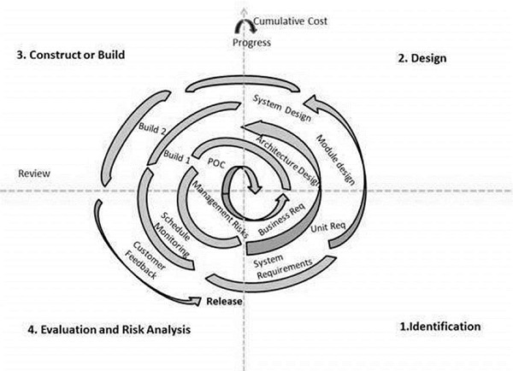

Based on the customer evaluation, the software development process enters the next iteration and subsequently follows the linear approach to implement the feedback suggested by the customer. The process of iterations along the spiral continues throughout the life of the software.

## Spiral Model Application

The Spiral Model is widely used in the software industry as it is in sync with the natural development process of any product, i.e. learning with maturity which involves minimum risk for the customer as well as the development firms.

The following pointers explain the typical uses of a Spiral Model −

* When there is a budget constraint and risk evaluation is important.
* For medium to high-risk projects.
* Long-term project commitment because of potential changes to economic priorities as the requirements change with time.
* Customer is not sure of their requirements which is usually the case.
* Requirements are complex and need evaluation to get clarity.
* New product line which should be released in phases to get enough customer feedback.
* Significant changes are expected in the product during the development cycle.

## Spiral Model - Pros and Cons

The advantage of spiral lifecycle model is that it allows elements of the product to be added in, when they become available or known. This assures that there is no conflict with previous requirements and design.

This method is consistent with approaches that have multiple software builds and releases which allows making an orderly transition to a maintenance activity. Another positive aspect of this method is that the spiral model forces an early user involvement in the system development effort.

On the other side, it takes a very strict management to complete such products and there is a risk of running the spiral in an indefinite loop. So, the discipline of change and the extent of taking change requests is very important to develop and deploy the product successfully.

The advantages of the Spiral SDLC Model are as follows −

* Changing requirements can be accommodated.
* Allows extensive use of prototypes.
* Requirements can be captured more accurately.
* Users see the system early.
* Development can be divided into smaller parts and the risky parts can be developed earlier which helps in better risk management.

The disadvantages of the Spiral SDLC Model are as follows −

* Management is more complex.
* End of the project may not be known early.
* Not suitable for small or low risk projects and could be expensive for small projects.
* Process is complex
* Spiral may go on indefinitely.
* Large number of intermediate stages requires excessive documentation.

**V-Model**

The V-model is an SDLC model where execution of processes happens in a sequential manner in a V-shape. It is also known as **Verification and Validation model**.

The V-Model is an extension of the waterfall model and is based on the association of a testing phase for each corresponding development stage. This means that for every single phase in the development cycle, there is a directly associated testing phase. This is a highly-disciplined model and the next phase starts only after completion of the previous phase.

## V-Model - Design

Under the V-Model, the corresponding testing phase of the development phase is planned in parallel. So, there are Verification phases on one side of the ‘V’ and Validation phases on the other side. The Coding Phase joins the two sides of the V-Model.

The following illustration depicts the different phases in a V-Model of the SDLC.

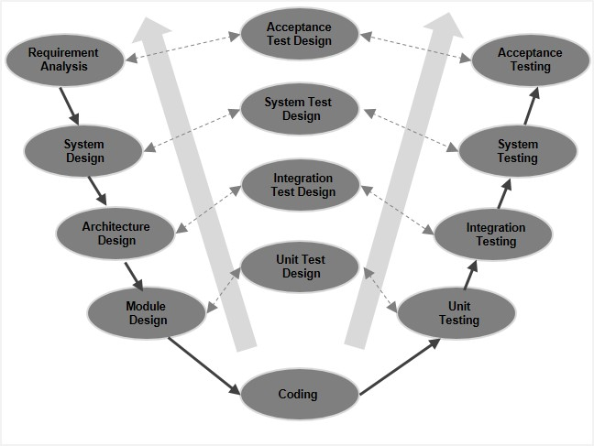

## V-Model - Verification Phases

There are several Verification phases in the V-Model, each of these are explained in detail below.

### **Business Requirement Analysis**

This is the first phase in the development cycle where the product requirements are understood from the customer’s perspective. This phase involves detailed communication with the customer to understand his expectations and exact requirement. This is a very important activity and needs to be managed well, as most of the customers are not sure about what exactly they need. The **acceptance test design planning** is done at this stage as business requirements can be used as an input for acceptance testing.

### **System Design**

Once you have the clear and detailed product requirements, it is time to design the complete system. The system design will have the understanding and detailing the complete hardware and communication setup for the product under development. The system test plan is developed based on the system design. Doing this at an earlier stage leaves more time for the actual test execution later.

### **Architectural Design**

Architectural specifications are understood and designed in this phase. Usually more than one technical approach is proposed and based on the technical and financial feasibility the final decision is taken. The system design is broken down further into modules taking up different functionality. This is also referred to as **High Level Design (HLD)**.

The data transfer and communication between the internal modules and with the outside world (other systems) is clearly understood and defined in this stage. With this information, integration tests can be designed and documented during this stage.

### **Module Design**

In this phase, the detailed internal design for all the system modules is specified, referred to as **Low Level Design (LLD)**. It is important that the design is compatible with the other modules in the system architecture and the other external systems. The unit tests are an essential part of any development process and helps eliminate the maximum faults and errors at a very early stage. These unit tests can be designed at this stage based on the internal module designs.

## Coding Phase

The actual coding of the system modules designed in the design phase is taken up in the Coding phase. The best suitable programming language is decided based on the system and architectural requirements.

The coding is performed based on the coding guidelines and standards. The code goes through numerous code reviews and is optimized for best performance before the final build is checked into the repository.

## Validation Phases

The different Validation Phases in a V-Model are explained in detail below.

### **Unit Testing**

Unit tests designed in the module design phase are executed on the code during this validation phase. Unit testing is the testing at code level and helps eliminate bugs at an early stage, though all defects cannot be uncovered by unit testing.

### **Integration Testing**

Integration testing is associated with the architectural design phase. Integration tests are performed to test the coexistence and communication of the internal modules within the system.

### **System Testing**

System testing is directly associated with the system design phase. System tests check the entire system functionality and the communication of the system under development with external systems. Most of the software and hardware compatibility issues can be uncovered during this system test execution.

### **Acceptance Testing**

Acceptance testing is associated with the business requirement analysis phase and involves testing the product in user environment. Acceptance tests uncover the compatibility issues with the other systems available in the user environment. It also discovers the non-functional issues such as load and performance defects in the actual user environment.

## V- Model ─ Application

V- Model application is almost the same as the waterfall model, as both the models are of sequential type. Requirements have to be very clear before the project starts, because it is usually expensive to go back and make changes. This model is used in the medical development field, as it is strictly a disciplined domain.

The following pointers are some of the most suitable scenarios to use the V-Model application.

* Requirements are well defined, clearly documented and fixed.
* Product definition is stable.
* Technology is not dynamic and is well understood by the project team.
* There are no ambiguous or undefined requirements.
* The project is short.

## V-Model - Pros and Cons

The advantage of the V-Model method is that it is very easy to understand and apply. The simplicity of this model also makes it easier to manage. The disadvantage is that the model is not flexible to changes and just in case there is a requirement change, which is very common in today’s dynamic world, it becomes very expensive to make the change.

The advantages of the V-Model method are as follows −

* This is a highly-disciplined model and Phases are completed one at a time.
* Works well for smaller projects where requirements are very well understood.
* Simple and easy to understand and use.
* Easy to manage due to the rigidity of the model. Each phase has specific deliverables and a review process.

The disadvantages of the V-Model method are as follows −

* High risk and uncertainty.
* Not a good model for complex and object-oriented projects.
* Poor model for long and ongoing projects.
* Not suitable for the projects where requirements are at a moderate to high risk of changing.
* Once an application is in the testing stage, it is difficult to go back and change a functionality.
* No working software is produced until late during the life cycle.

**Big Bang Model**

The Big Bang model is an SDLC model where we do not follow any specific process. The development just starts with the required money and efforts as the input, and the output is the software developed which may or may not be as per customer requirement. This Big Bang Model does not follow a process/procedure and there is a very little planning required. Even the customer is not sure about what exactly he wants and the requirements are implemented on the fly without much analysis.

Usually this model is followed for small projects where the development teams are very small.

## Big Bang Model ─ Design and Application

The Big Bang Model comprises of focusing all the possible resources in the software development and coding, with very little or no planning. The requirements are understood and implemented as they come. Any changes required may or may not need to revamp the complete software.

This model is ideal for small projects with one or two developers working together and is also useful for academic or practice projects. It is an ideal model for the product where requirements are not well understood and the final release date is not given.

## Big Bang Model - Pros and Cons

The advantage of this Big Bang Model is that it is very simple and requires very little or no planning. Easy to manage and no formal procedure are required.

However, the Big Bang Model is a very high risk model and changes in the requirements or misunderstood requirements may even lead to complete reversal or scraping of the project. It is ideal for repetitive or small projects with minimum risks.

The advantages of the Big Bang Model are as follows −

* This is a very simple model
* Little or no planning required
* Easy to manage
* Very few resources required
* Gives flexibility to developers
* It is a good learning aid for new comers or students.

The disadvantages of the Big Bang Model are as follows −

* Very High risk and uncertainty.
* Not a good model for complex and object-oriented projects.
* Poor model for long and ongoing projects.
* Can turn out to be very expensive if requirements are misunderstood.

**Agile Model**

Agile SDLC model is a combination of iterative and incremental process models with focus on process adaptability and customer satisfaction by rapid delivery of working software product. Agile Methods break the product into small incremental builds. These builds are provided in iterations. Each iteration typically lasts from about one to three weeks. Every iteration involves cross functional teams working simultaneously on various areas like −

* Planning
* Requirements Analysis
* Design
* Coding
* Unit Testing and
* Acceptance Testing.

At the end of the iteration, a working product is displayed to the customer and important stakeholders.

What is Agile?

Agile model believes that every project needs to be handled differently and the existing methods need to be tailored to best suit the project requirements. In Agile, the tasks are divided to time boxes (small time frames) to deliver specific features for a release.

Iterative approach is taken and working software build is delivered after each iteration. Each build is incremental in terms of features; the final build holds all the features required by the customer.

Here is a graphical illustration of the Agile Model −

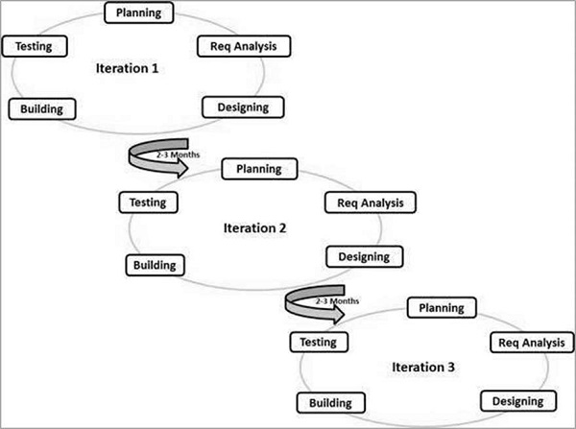

The Agile thought process had started early in the software development and started becoming popular with time due to its flexibility and adaptability.

The most popular Agile methods include Rational Unified Process (1994), Scrum (1995), Crystal Clear, Extreme Programming (1996), Adaptive Software Development, Feature Driven Development, and Dynamic Systems Development Method (DSDM) (1995). These are now collectively referred to as **Agile Methodologies**, after the Agile Manifesto was published in 2001.

Following are the Agile Manifesto principles −

* **Individuals and interactions** − In Agile development, self-organization and motivation are important, as are interactions like co-location and pair programming.
* **Working software** − Demo working software is considered the best means of communication with the customers to understand their requirements, instead of just depending on documentation.
* **Customer collaboration** − As the requirements cannot be gathered completely in the beginning of the project due to various factors, continuous customer interaction is very important to get proper product requirements.
* **Responding to change** − Agile Development is focused on quick responses to change and continuous development.

Agile Vs Traditional SDLC Models

Agile is based on the **adaptive software development methods**, whereas the traditional SDLC models like the waterfall model is based on a predictive approach. Predictive teams in the traditional SDLC models usually work with detailed planning and have a complete forecast of the exact tasks and features to be delivered in the next few months or during the product life cycle.

Predictive methods entirely depend on the **requirement analysis and planning** done in the beginning of cycle. Any changes to be incorporated go through a strict change control management and prioritization.

Agile uses an **adaptive approach** where there is no detailed planning and there is clarity on future tasks only in respect of what features need to be developed. There is feature driven development and the team adapts to the changing product requirements dynamically. The product is tested very frequently, through the release iterations, minimizing the risk of any major failures in future.

**Customer Interaction** is the backbone of this Agile methodology, and open communication with minimum documentation are the typical features of Agile development environment. The agile teams work in close collaboration with each other and are most often located in the same geographical location.

Agile Model - Pros and Cons

Agile methods are being widely accepted in the software world recently. However, this method may not always be suitable for all products. Here are some pros and cons of the Agile model.

The advantages of the Agile Model are as follows −

* Is a very realistic approach to software development.
* Promotes teamwork and cross training.
* Functionality can be developed rapidly and demonstrated.
* Resource requirements are minimum.
* Suitable for fixed or changing requirements
* Delivers early partial working solutions.
* Good model for environments that change steadily.
* Minimal rules, documentation easily employed.
* Enables concurrent development and delivery within an overall planned context.
* Little or no planning required.
* Easy to manage.
* Gives flexibility to developers.

The disadvantages of the Agile Model are as follows −

* Not suitable for handling complex dependencies.
* More risk of sustainability, maintainability and extensibility.
* An overall plan, an agile leader and agile PM practice is a must without which it will not work.
* Strict delivery management dictates the scope, functionality to be delivered, and adjustments to meet the deadlines.
* Depends heavily on customer interaction, so if customer is not clear, team can be driven in the wrong direction.
* There is a very high individual dependency, since there is minimum documentation generated.
* Transfer of technology to new team members may be quite challenging due to lack of documentation.

**RAD Model ( Rapid Application Development Model )**

The **RAD (Rapid Application Development)** model is based on prototyping and iterative development with no specific planning involved. The process of writing the software itself involves the planning required for developing the product.

Rapid Application Development focuses on gathering customer requirements through workshops or focus groups, early testing of the prototypes by the customer using iterative concept, reuse of the existing prototypes (components), continuous integration and rapid delivery.

## What is RAD?

Rapid application development is a software development methodology that uses minimal planning in favor of rapid prototyping. A prototype is a working model that is functionally equivalent to a component of the product.

In the RAD model, the functional modules are developed in parallel as prototypes and are integrated to make the complete product for faster product delivery. Since there is no detailed preplanning, it makes it easier to incorporate the changes within the development process.

RAD projects follow iterative and incremental model and have small teams comprising of developers, domain experts, customer representatives and other IT resources working progressively on their component or prototype.

The most important aspect for this model to be successful is to make sure that the prototypes developed are reusable.

## RAD Model Design

RAD model distributes the analysis, design, build and test phases into a series of short, iterative development cycles.

Following are the various phases of the RAD Model −

### **Business Modelling**

The business model for the product under development is designed in terms of flow of information and the distribution of information between various business channels. A complete business analysis is performed to find the vital information for business, how it can be obtained, how and when is the information processed and what are the factors driving successful flow of information.

### **Data Modelling**

The information gathered in the Business Modelling phase is reviewed and analyzed to form sets of data objects vital for the business. The attributes of all data sets is identified and defined. The relation between these data objects are established and defined in detail in relevance to the business model.

### **Process Modelling**

The data object sets defined in the Data Modelling phase are converted to establish the business information flow needed to achieve specific business objectives as per the business model. The process model for any changes or enhancements to the data object sets is defined in this phase. Process descriptions for adding, deleting, retrieving or modifying a data object are given.

### **Application Generation**

The actual system is built and coding is done by using automation tools to convert process and data models into actual prototypes.

### **Testing and Turnover**

The overall testing time is reduced in the RAD model as the prototypes are independently tested during every iteration. However, the data flow and the interfaces between all the components need to be thoroughly tested with complete test coverage. Since most of the programming components have already been tested, it reduces the risk of any major issues.

The following illustration describes the RAD Model in detail.

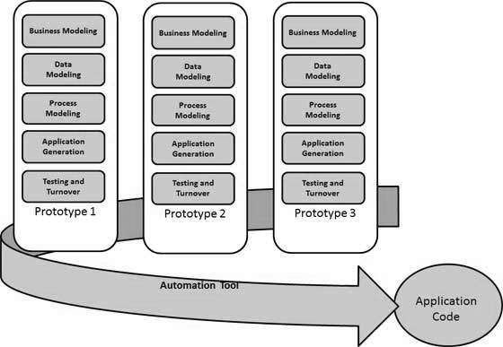

## RAD Model Vs Traditional SDLC

The traditional SDLC follows a rigid process models with high emphasis on requirement analysis and gathering before the coding starts. It puts pressure on the customer to sign off the requirements before the project starts and the customer doesn’t get the feel of the product as there is no working build available for a long time.

The customer may need some changes after he gets to see the software. However, the change process is quite rigid and it may not be feasible to incorporate major changes in the product in the traditional SDLC.

The RAD model focuses on iterative and incremental delivery of working models to the customer. This results in rapid delivery to the customer and customer involvement during the complete development cycle of product reducing the risk of non-conformance with the actual user requirements.

## RAD Model - Application

RAD model can be applied successfully to the projects in which clear modularization is possible. If the project cannot be broken into modules, RAD may fail.

The following pointers describe the typical scenarios where RAD can be used −

* RAD should be used only when a system can be modularized to be delivered in an incremental manner.
* It should be used if there is a high availability of designers for Modelling.
* It should be used only if the budget permits use of automated code generating tools.
* RAD SDLC model should be chosen only if domain experts are available with relevant business knowledge.
* Should be used where the requirements change during the project and working prototypes are to be presented to customer in small iterations of 2-3 months.

## RAD Model - Pros and Cons

RAD model enables rapid delivery as it reduces the overall development time due to the reusability of the components and parallel development. RAD works well only if high skilled engineers are available and the customer is also committed to achieve the targeted prototype in the given time frame. If there is commitment lacking on either side the model may fail.

The advantages of the RAD Model are as follows −

* Changing requirements can be accommodated.
* Progress can be measured.
* Iteration time can be short with use of powerful RAD tools.
* Productivity with fewer people in a short time.
* Reduced development time.
* Increases reusability of components.
* Quick initial reviews occur.
* Encourages customer feedback.
* Integration from very beginning solves a lot of integration issues.

The disadvantages of the RAD Model are as follows −

* Dependency on technically strong team members for identifying business requirements.
* Only system that can be modularized can be built using RAD.
* Requires highly skilled developers/designers.
* High dependency on Modelling skills.
* Inapplicable to cheaper projects as cost of Modelling and automated code generation is very high.
* Management complexity is more.
* Suitable for systems that are component based and scalable.
* Requires user involvement throughout the life cycle.
* Suitable for project requiring shorter development times.

**Software Prototyping**

The Software Prototyping refers to building software application prototypes which displays the functionality of the product under development, but may not actually hold the exact logic of the original software.

Software prototyping is becoming very popular as a software development model, as it enables to understand customer requirements at an early stage of development. It helps get valuable feedback from the customer and helps software designers and developers understand about what exactly is expected from the product under development.

## What is Software Prototyping?

Prototype is a working model of software with some limited functionality. The prototype does not always hold the exact logic used in the actual software application and is an extra effort to be considered under effort estimation.

Prototyping is used to allow the users evaluate developer proposals and try them out before implementation. It also helps understand the requirements which are user specific and may not have been considered by the developer during product design.

Following is a stepwise approach explained to design a software prototype.

### **Basic Requirement Identification**

This step involves understanding the very basics product requirements especially in terms of user interface. The more intricate details of the internal design and external aspects like performance and security can be ignored at this stage.

### **Developing the initial Prototype**

The initial Prototype is developed in this stage, where the very basic requirements are showcased and user interfaces are provided. These features may not exactly work in the same manner internally in the actual software developed. While, the workarounds are used to give the same look and feel to the customer in the prototype developed.

### **Review of the Prototype**

The prototype developed is then presented to the customer and the other important stakeholders in the project. The feedback is collected in an organized manner and used for further enhancements in the product under development.

### **Revise and Enhance the Prototype**

The feedback and the review comments are discussed during this stage and some negotiations happen with the customer based on factors like – time and budget constraints and technical feasibility of the actual implementation. The changes accepted are again incorporated in the new Prototype developed and the cycle repeats until the customer expectations are met.

Prototypes can have horizontal or vertical dimensions. A Horizontal prototype displays the user interface for the product and gives a broader view of the entire system, without concentrating on internal functions. A Vertical prototype on the other side is a detailed elaboration of a specific function or a sub system in the product.

The purpose of both horizontal and vertical prototype is different. Horizontal prototypes are used to get more information on the user interface level and the business requirements. It can even be presented in the sales demos to get business in the market. Vertical prototypes are technical in nature and are used to get details of the exact functioning of the sub systems. For example, database requirements, interaction and data processing loads in a given sub system.

## Software Prototyping - Types

There are different types of software prototypes used in the industry. Following are the major software prototyping types used widely −

### **Throwaway/Rapid Prototyping**

Throwaway prototyping is also called as rapid or close ended prototyping. This type of prototyping uses very little efforts with minimum requirement analysis to build a prototype. Once the actual requirements are understood, the prototype is discarded and the actual system is developed with a much clear understanding of user requirements.

### **Evolutionary Prototyping**

Evolutionary prototyping also called as breadboard prototyping is based on building actual functional prototypes with minimal functionality in the beginning. The prototype developed forms the heart of the future prototypes on top of which the entire system is built. By using evolutionary prototyping, the well-understood requirements are included in the prototype and the requirements are added as and when they are understood.

### **Incremental Prototyping**

Incremental prototyping refers to building multiple functional prototypes of the various sub-systems and then integrating all the available prototypes to form a complete system.

### **Extreme Prototyping**

Extreme prototyping is used in the web development domain. It consists of three sequential phases. First, a basic prototype with all the existing pages is presented in the HTML format. Then the data processing is simulated using a prototype services layer. Finally, the services are implemented and integrated to the final prototype. This process is called Extreme Prototyping used to draw attention to the second phase of the process, where a fully functional UI is developed with very little regard to the actual services.

## Software Prototyping - Application

Software Prototyping is most useful in development of systems having high level of user interactions such as online systems. Systems which need users to fill out forms or go through various screens before data is processed can use prototyping very effectively to give the exact look and feel even before the actual software is developed.

Software that involves too much of data processing and most of the functionality is internal with very little user interface does not usually benefit from prototyping. Prototype development could be an extra overhead in such projects and may need lot of extra efforts.

## Software Prototyping - Pros and Cons

Software prototyping is used in typical cases and the decision should be taken very carefully so that the efforts spent in building the prototype add considerable value to the final software developed. The model has its own pros and cons discussed as follows.

The advantages of the Prototyping Model are as follows −

* Increased user involvement in the product even before its implementation.
* Since a working model of the system is displayed, the users get a better understanding of the system being developed.
* Reduces time and cost as the defects can be detected much earlier.
* Quicker user feedback is available leading to better solutions.
* Missing functionality can be identified easily.
* Confusing or difficult functions can be identified.

The Disadvantages of the Prototyping Model are as follows −

* Risk of insufficient requirement analysis owing to too much dependency on the prototype.
* Users may get confused in the prototypes and actual systems.
* Practically, this methodology may increase the complexity of the system as scope of the system may expand beyond original plans.
* Developers may try to reuse the existing prototypes to build the actual system, even when it is not technically feasible.
* The effort invested in building prototypes may be too much if it is not monitored properly.